UNIVERSITY OF LA VERNE

LA VERNE, CALIFORNIA

FALL 2018

SENIOR PROJECT

**RISE ABOVE LEARNING**

URL = RISEABOVELEARNING.ELEDONTA.COM

A SENIOR PROJECT SUBMITTED TO:

THE FACULTY OF

COMPUTER SCIENCE AND COMPUTER ENGINEERING

IN CANDIDANCY FOR THE DEGREE OF

BACHELORS OF SCIENCE

COMPUTER SCIENCE AND COMPUTER ENGINEERING

WITH A CONCENTRATION IN INTERNET PROGRAMMING

BY

AMBER KIMBERLING

UNIVERSITY PROJECT ADVISOR:

PROF. JOZEF GOETZ

**ACKNOWLEDGEMENTS**

This work would not have been possible without the support of the Computer Science department at the University of La Verne. I am especially thankful to Faria Raji(my mentor), Hawk Engvig(professor of web design at the Fashion Institute of Design and Merchandising),

my fellow classmates, and Professor Jozef Goetz who have all been supportive of my career goals and who worked actively to provide me with the protected academic time to pursue those goals. I am grateful to all of those with whom I have worked with during this and other classes. I would especially like to thank Professor Jozef Goetz, the Internet Programming advisor and professor. As my professor, he has taught me more than I could ever give him credit for.

**TABLE OF CONTENTS**

Abstract 1

1. Introduction 1

2. Background 1

3. Analysis and Requirements 2

4. Design 3

5. Implementation 10

6. Test and Integration 50

7. Conclusion 60

8. References 61

9. Appendices 61

DB **name:** raldb

DB **login:** raldb_user

DB **password:** ral3@1996$$

**All privileges admin name:** Lily Girl

**All privileges admin login:** lgirl@gmail.com

**All privileges admin password:** lily

# **Abstract**

The purpose of this project is to develop a web application that allows teachers to quiz students on different topics. This web application uses a relational database management system, MySQL. The data in the database is organized in a way that a user is related to quizzes and categories and each category is related to many quizzes(quizzes can also be related to many categories, it is a many to many relationship). The users consist of students and teachers who are differentiated by their permissions. The teachers manage everything including all user permissions, quizzes, and categories and the students may only add a category they would like a teacher to add quizzes to and take quizzes. This web application includes password protected administration capabilities that include: viewing, adding, editing, and deleting quizzes or categories. These capabilities all belong to the teachers and a few of them to the students such as adding and editing the categories that they created. The website also has a quiz taking page associated with each topic such as physics or history. The website includes a variety of other pages including a home page, about, Q&A, and a contact page. This website is developed using HTML, CSS, PHP, JavaScript, and jQuery.

# **Introduction**

The proposed project is about allowing teachers to give their students to actively practice the materials from in class by giving them practice quizzes. Students need a place where they can become more comfortable and confident with exams and quizzes. This web application will be used to introduce material from teachers to the students in an active manor. The problem is there isn’t a current user-friendly web application for teachers to test their students with the material specific to a class. Today there are a lot of applications that test students but fail to be consistent with specific material and the level of difficulty from a topic. The goal of this project is to develop a web application that provides quizzes, results, and allows user to take it as many as times as they need. A relational database will be used that consists of quizzes, categories, and users. The web application will include administration capabilities, which will allow educators to set permissions, edit, delete, and insert. The website will consist of multiple web pages that will limit accessibility depending on your permissions as a user. Educators will have access to all pages including manage users, quizzes, and categories. Overall the purpose of this web application is to test students in a positive psychologically stimulating way through quizzes that provide feedback.

# **Background/Literature Review**

In order to create the web application, I studied various coding languages through course work. Although I had some prior knowledge of web development, the main source of literature I used to develop my web app was *PHP & MySQL Novice to Ninja* by Tom Butler and Kevin Yank. The book described how to build a database with tables through SQL statements and how to connect it with your website. It also went through various techniques on how write php with user access and administration access. This was key in my project to create the two types of users that differentiated by privileges. Another piece of literature that was useful in referencing html and accessibility standards in *Web Development and Design Foundations* by Terry Felke-Morris. I used it as guidelines for general web requirements and references to code that helps create a good accessible website.

# **Analysis and Requirements**

1. Web Page Design
   1. The website conforms to the Web Design Best Practices Checklist

[**http://terrymorris.net/bestpractices**](http://terrymorris.net/bestpractices)

1. Website Navigation
2. The navigation is consistent throughout every page
3. A text based navigation is implemented in the footer for users who are disabled
4. Page Layout Design
   1. The website appeals to the audience who will be viewing it
   2. The website has a consistent header/footer/navigation throughout each page
   3. Pertinent page information is located in the footer
   4. Page is viewable in 1024x768 resolution with no horizontal scrolling
   5. The contrast between the background and content is strong to ensure ease while reading
   6. The website has a logical alignment of content
   7. The homepage of the website loads in a reasonable amount of time for a 56 kbps connection
   8. There is a good balance between content and whitespace
   9. Optimized layout for mobile use as follows:
      * 1. Single column design
        2. Limit scrolling to one direction
        3. Use heading elements
        4. Use lists
5. Color and Graphics
   * 1. The color of the website is appealing to the eye, but maintains a loose business feeling (no dark colors)
     2. Color is used consistently throughout the entire website
     3. Color is not be used exclusively to convey meaning
     4. Graphics don’t have a significant impact on the loading time of the website
     5. The alt attribute is used on all images
6. Content Presentation
   * 1. Information is easy to find within the website
     2. Common fonts are used (Times New Roman, Arial, Sans serif, etc.)
     3. Content organization follows a consistent pattern
     4. Font sizes, font color, and font style remains consistent
7. Accessibility
   * 1. The alt tag is used on any images or videos
     2. Captions should be used on any video content
     3. “Web safe” colors are used
     4. Proper navigation is used to help accessibility (bread crumb trails, text based navigation)
8. Special Requirements
   * 1. The website provides for the owner to easily update, create, delete, etc. pages in a quick and simple way
     2. The website provides a means of communication between the users of the website
9. Mobile Best Practice Requirements

The website conforms to the best practices on the following:

<http://www.w3.org/2007/02/mwbp_flip_cards.html>

<https://www.sitepoint.com/7-best-practices-designing-mobile-user-experience/>

<https://designmodo.com/responsive-design-examples/>

# **Design**

1. Sitemap – A list of the webpages and their connection to each other.

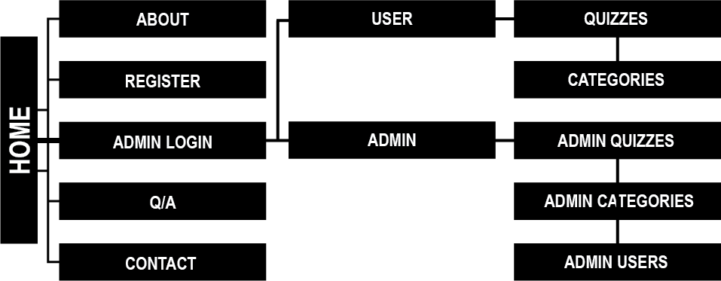

1. Wireframes – A skeletal model of each page structure at different media sizes.

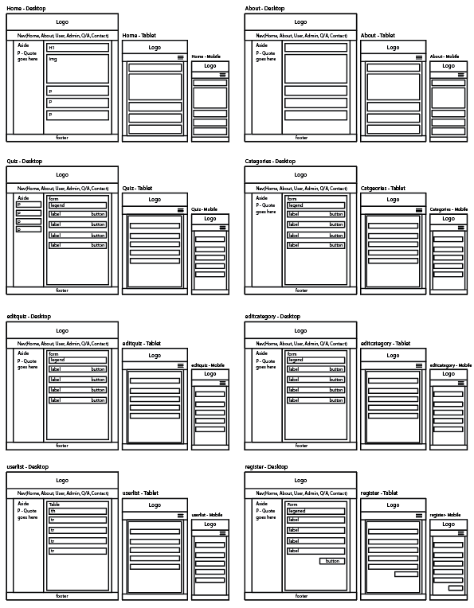

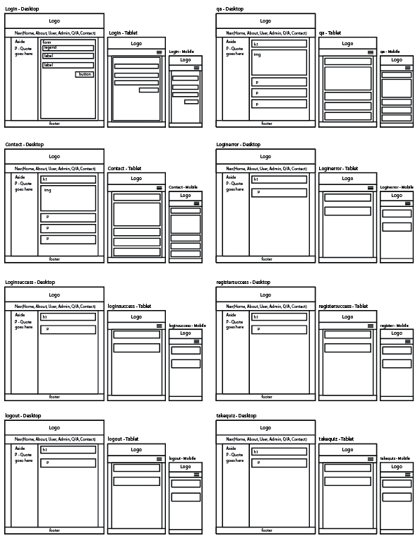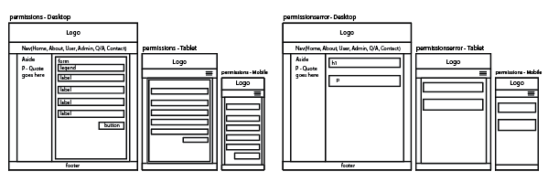

1. Illustrated Model of Website – Illustrator constructed webpage



1. Website Interface – Each webpages interface

|  |  |
| --- | --- |
| Home | About |
| User - Quizzes | User – Categories |
| User – Quizzes – Take quiz | Admin – Categories |
| Admin – Quizzes | Admin – Users |
| Admin – Users – Permissions | Registration |
| Sign In | Q/A |
| Contact |  |

1. Database Relationship Table – shows how each table in the database is related

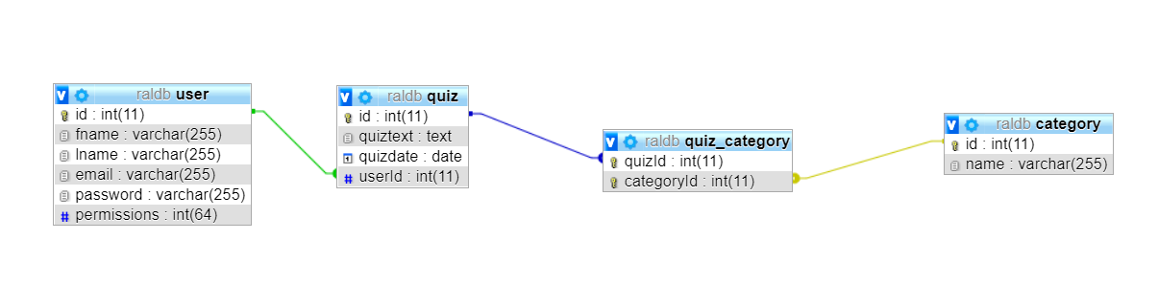

1. User Case Diagram – shows the actions different users can do

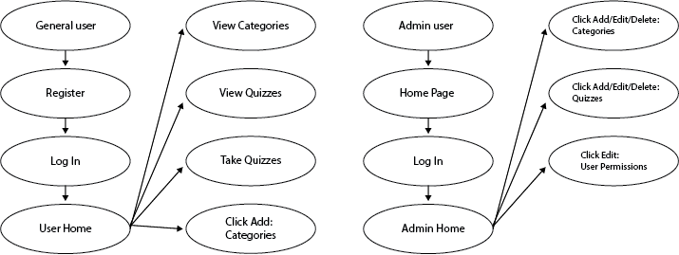

1. Functional Flow Diagram – shows the movement of each user

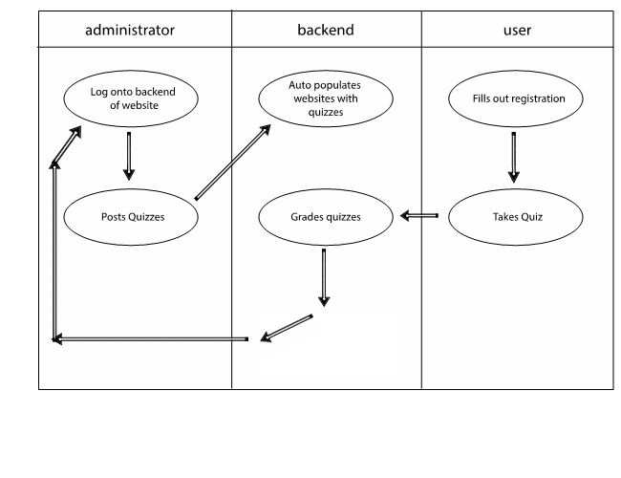

# **Implementation**

1. Web Page Design

a. The website is designed to ensure that the conditions of the web design best practices are met. These conditions were kept in mind while editing and creating new pages.

1. Website Navigation
   1. The website has multiple sources of navigation.  First, there is the main navigation that is at the top of the website.  There is a text-based navigation in the footer to allow for accessibility for those who are disabled or who do not have browsers with CSS capabilities.
2. Page Layout Design
   * 1. Cascading Style Sheets is used to create a two-column structure which will allow for maximum functionality and multiple places to put information.
     2. Media queries configure **responsive page layout** for **smartphone** and **tablet display.**
     3. A Liquid design is used in order to adapt itself to the available white space, which may vary between people using different resolutions.
     4. The website is designed with the Arial font and colors that are contrasting.  That allow for maximum accessibility.
     5. Most of the important information is located above the fold so that it is faster to access.
     6. Website is designed with multiple resolutions in mind to ensure accessibility to those with lower resolution monitors.  Also, white space is balanced for those who do have access to larger resolutions.
     7. The website is designed to load in a reasonable amount of time (usually under 10 seconds) for those who are on dial up.  A perceived load time faster than that would be ideal.
3. Color and Graphics
   * 1. Color is appealing but still maintain a business-like feeling.  Dark colors are avoided, as will very bright colors that might be hard to read or give certain individuals problems with reading.  Web safe colors are used to ensure that all users see the same color.
     2. Color is used consistently throughout the entire site.
     3. Color were not used to convey meaning alone.
     4. The alt attribute is used on all videos and pictures.
     5. The graphics are optimized to ensure that the load time of the website is not severely affected.
4. Content Presentation
   * 1. Most important information is located “above the fold” to ensure that information can be found quickly and easily and the user does not have to do a lot of scrolling.
     2. Colors and themes are used consistently throughout every page.
     3. Arial font is used.  A widely supported font.
     4. Major changes were not be made to the organization of a page. The organizational structure of the page will stay consistent.
5. Accessibility
   * 1. Captions are used on all videos.
6. Database implementation – All the SQL statements that were used to create a table

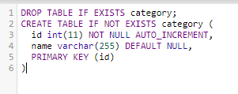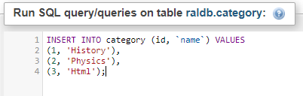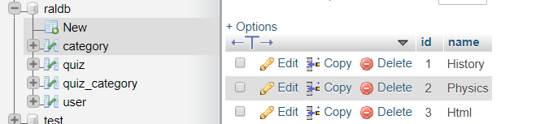

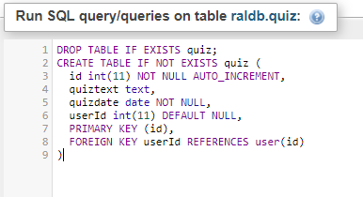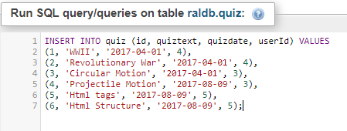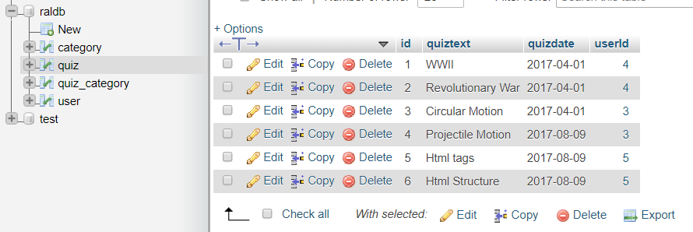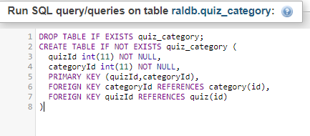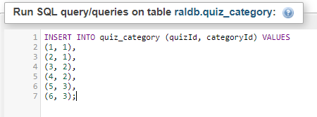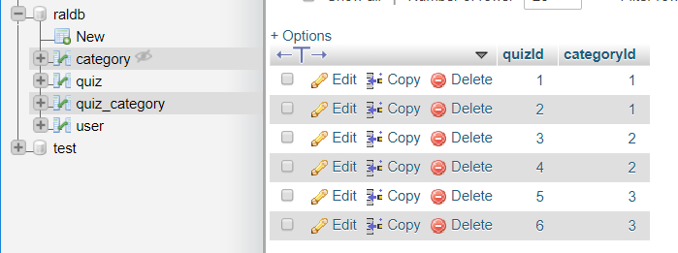

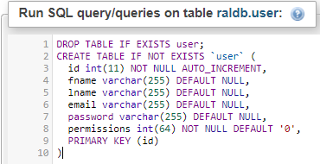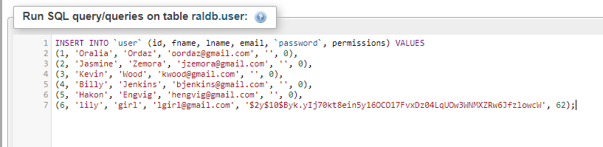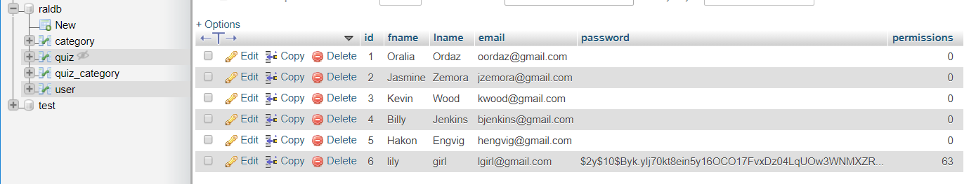

1. SQL file – All the SQL statements used in order to create the database

SET SQL_MODE = "NO_AUTO_VALUE_ON_ZERO";

/*!40101 SET @OLD_CHARACTER_SET_CLIENT=@@CHARACTER_SET_CLIENT */;

/*!40101 SET @OLD_CHARACTER_SET_RESULTS=@@CHARACTER_SET_RESULTS */;

/*!40101 SET @OLD_COLLATION_CONNECTION=@@COLLATION_CONNECTION */;/*!40101 SET NAMES utf8mb4 */;

CREATE DATABASE IF NOT EXISTS raldb DEFAULT CHARACTER SET latin1 COLLATE latin1_swedish_ci;

USE raldb;

DROP TABLE IF EXISTS category;

CREATE TABLE IF NOT EXISTS category (

id int(11) NOT NULL AUTO_INCREMENT,

name varchar(255) DEFAULT NULL,

PRIMARY KEY (id)

) ENGINE=InnoDB DEFAULT CHARSET=latin1;

INSERT INTO category (id, `name`) VALUES

(1, 'History'),

(2, 'Physics'),

(3, 'Html');

DROP TABLE IF EXISTS quiz;

CREATE TABLE IF NOT EXISTS quiz (

id int(11) NOT NULL AUTO_INCREMENT,

quiztext text,

quizdate date NOT NULL,

userId int(11) DEFAULT NULL,

PRIMARY KEY (id),

FOREIGN KEY userId REFERENCES user(id)

) ENGINE=InnoDB DEFAULT CHARSET=utf8;

INSERT INTO quiz (id, quiztext, quizdate, userId) VALUES

(1, 'WWII', '2017-04-01', 4),

(2, 'Revolutionary War', '2017-04-01', 4),

(3, 'Circular Motion', '2017-04-01', 3),

(4, 'Projectile Motion', '2017-08-09', 3),

(5, 'Html tags', '2017-08-09', 5),

(6, 'Html Structure', '2017-08-09', 5);

DROP TABLE IF EXISTS quiz_category;

CREATE TABLE IF NOT EXISTS quiz_category (

quizId int(11) NOT NULL,

categoryId int(11) NOT NULL,

PRIMARY KEY (quizId,categoryId),

FOREIGN KEY categoryId REFERENCES category(id),

FOREIGN KEY quizId REFERENCES quiz(id)

) ENGINE=InnoDB DEFAULT CHARSET=latin1;

INSERT INTO quiz_category (quizId, categoryId) VALUES

(1, 1),

(2, 1),

(3, 2),

(4, 2),

(5, 3),

(6, 3);

DROP TABLE IF EXISTS user;

CREATE TABLE IF NOT EXISTS `user` (

id int(11) NOT NULL AUTO_INCREMENT,

fname varchar(255) DEFAULT NULL,

lname varchar(255) DEFAULT NULL,

email varchar(255) DEFAULT NULL,

password varchar(255) DEFAULT NULL,

permissions int(64) NOT NULL DEFAULT '0',

PRIMARY KEY (id)

) ENGINE=InnoDB DEFAULT CHARSET=utf8;

INSERT INTO `user` (id, fname, lname, email, `password`, permissions) VALUES

(1, 'Oralia', 'Ordaz', 'oordaz@gmail.com', '', 0),

(2, 'Jasmine', 'Zemora', 'jzemora@gmail.com', '', 0),

(3, 'Kevin', 'Wood', 'kwood@gmail.com', '', 0),

(4, 'Billy', 'Jenkins', 'bjenkins@gmail.com', '', 0),

(5, 'Hakon', 'Engvig', 'hengvig@gmail.com', '', 0),

(6, 'lily', 'girl', 'lgirl@gmail.com', '$2y$10$Byk.yIj70kt8ein5y16OCO17FvxDz04LqUOw3WNMXZRw6JfzlowcW', 62);

/*!40101 SET CHARACTER_SET_CLIENT=@OLD_CHARACTER_SET_CLIENT */;

/*!40101 SET CHARACTER_SET_RESULTS=@OLD_CHARACTER_SET_RESULTS */;

/*!40101 SET COLLATION_CONNECTION=@OLD_COLLATION_CONNECTION */;

1. File Structure – the structures of the files containing the pages that make up the website.

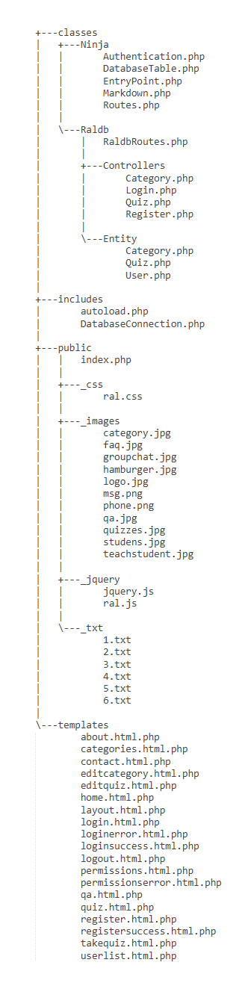

1. Graphical Hierarchy of Files and Relationships

|  |  |  |  |
| --- | --- | --- | --- |
| **Directories**  **Rise Above Learning** | **File Names with a short description** | **“Includes” File Names and Function Names** | **Included**  **Headers** |
| **includes** | **DatabaseConnection**.php – connect to the database and supply a connection string parameters such as a **host** **name**, a **databasename**, an **user name** and a **password.** |  |  |
|  | **autuoload.php -** enabling for classes to be automatically loaded if they aren’t currently defined. By registering the autoloaders, it is a last chance to load the class before it fails. | function autoloader($className) |  |
| **templates** | **addquiz**.php – inserts a quiz that was from **addquiz**.html.php into the database database.sql, calls insertquiz() | **DatabaseConnection**.php  **autoload**.php  insertquiz()  **addquiz**.html.php  **layout**.html.php | **quizzes**.php |
|  | **deletequiz**.php – deletes a quiz when the delete button is pressed in quizzes.html.php, calls deletequiz() | **DatabaseConnection**.php  **autoload**.php  deletequiz ()  layout.html.php | **quizzes**.php |
|  | **users**.html.php –  where the list of users are displayed. |  |  |
|  | **categories**.html.php –  list of categories displayed here |  |  |
|  | **editcategory**.html.php –  allows admin to input a new category |  |  |
|  | **editquiz**.html.php –  displays editing capabilities. |  |  |
|  | **home.**html.php –  displays the title of the current page. |  |  |
|  | **quizzes**.html.php –  displays the quizzes students can take |  |  |
|  | **layout**.html.php –  basic layout for all pages. |  |  |
|  | **login**.html.php –  includes the textboxes to login into admin |  |  |
|  | **loginsuccess**.html.php –  displays that the user is successfully logged in. |  |  |
|  | **loginerror**.html.php –  displays that the user is not logged in. |  |  |
|  | **permissions**.html.php –  displays the permissions certain users have. |  |  |
|  | **permissionserror**.html.php –  displays that the user does not have the permission to view this page. |  |  |
|  | **register**.html.php –  displays the form for users to enter in their information and register an account |  |  |
|  | **registersuccess**.html.php –  displays that the registered successfully |  |  |
|  | **logout**.html.php –  displays that the user is logged out. |  |  |
|  | **takequiz**.html.php –  displays a txt using php that has a quiz on it and grades it using JavaScript |  |  |
| **public** | **index.**php **–**  uses a try and catch block to catch an error if the page does not load |  |  |
|  | **home.**css **-**  all the styling for the entire website |  |  |
| **classes - ral** | **ralRoutes**.php –  navigation through the website and uses functions to check permissions and authentication. | **public function __construct()**  **public function getRoutes(): array**  **public function getAuthentication():**  **public function checkPermission($permission): bool** |  |
| **classes – ral - controllers** | **Category.php**  using functions to allow the categories to be edited, deleted, entered, and displayed in a list | **public function __construct(\Ninja\DatabaseTable $categoriesTable, \Ninja\DatabaseTable $quizCategoriesTable)**  **function edit()**  **public function saveEdit()**  **public function list()**  **public function delete()** | **header('location: index.php?category/list')**  **header('location: index.php?category/list')** |
|  | **quiz.php –**  using functions to allow the quiz to be edited, deleted, entered, and displayed in a list | **public function __construct(DatabaseTable $quizTable, DatabaseTable $userssTable, DatabaseTable $categoriesTable,**  **DatabaseTable $quizCategoriesTable, Authentication $authentication)**  **public function list()**  **public function home()**  **public function delete()**  **public function saveEdit()**  **public function edit()** | **header('location: index.php?quiz/list')**  **header('location: index.php?quiz/list')** |
|  | **Register.php -**  uses functions to validate, display error or success messages, and permissions. | **public function __construct(DatabaseTable $usersTable)**  **public function registrationForm()**  **public function success()**  **public function registerUser()**  **public function list()**  **public function permissions()**  **public function savePermissions()** | **header('Location: index.php?user/success')**  **header('location: index.php?user/list')** |
|  | **Login.php -**  uses functions to validate, display error or success messages, and permissions. | **public function __construct(\Ninja\Authentication $authentication)**  **public function loginForm()**  **public function processLogin()**  **public function success()**  **public function error()**  **public function permissionsError()**  **public function logout()** | **header('Location: index.php?login/success')** |
| **classes - entity** | **user.php**  sets the user permissions and uses functions to set the permissions like show quizzes and allow editing capabilities. | **public function __construct(\Ninja\DatabaseTable $quizTable)** |  |
|  | **category.php –**  sorts through the quizzes and displays the number of quizzes | **public function __construct(DatabaseTable $quizTable, DatabaseTable $quizCategoriesTable)**  **public function getquiz($limit = null, $offset = null)**  **public function**  **getNumquiz()**  **private function sortquiz($a, $b)** |  |
|  | **quiz.php-**  takes a certain user and allows them only to edit what they have posted or added. | **public function __construct(\Ninja\DatabaseTable $quizTable, \Ninja\DatabaseTable $quizCategoriesTable)**  **public function getAuthor()**  **public function addCategory($categoryId)**  **public function hasCategory($categoryId)**  **public function clearCategories()** |  |
| **classes – ninja** | **authentification.php**  uses functions to authenticate users information | **public function __construct(DatabaseTable $users, $usernameColumn, $passwordColumn)**  **public function login($username, $password)**  **public function isLoggedIn()** |  |
|  | **DatabaseTable.php**  searches through the database tables and grabs specific information depending on if its quiz, category, users, etc. | **public function __construct(\PDO $pdo, string $table, string $primaryKey, string $className = '\stdClass', array $constructorArgs = [])**  **private function query($sql, $parameters = [])**  **public function total($field = null, $value = null)**  **public function findById($value)**  **public function find($column, $value, $orderBy = null, $limit = null, $offset = null)**  **private function insert($fields)**  **private function update($fields)**  **public function delete($id)**  **public function findAll($orderBy = null, $limit = null, $offset = null)**  **private function processDates($fields)**  **public function save($record)** |  |
|  | **EntryPoint.php**  checks the permissions in order to view certain pages in | **public function __construct(string $route, string $method, \Ninja\Routes $routes)**  **private function checkUrl()**  **private function loadTemplate($templateFileName, $variables = [])**  **public function run()** |  |
|  | **Markdown.php**  displays the proper format for specific inputs in a form. | **public function __construct($markDown)**  **public function toHtml()** |  |
|  | **Routes.php** | **public function getRoutes(): array;**  **public function getAuthentication(): \Ninja\Authentication;**  **public function checkPermission($permission): bool;** |  |

1. Key Source code – most important code

ral.css

/*RISE ABOVE LEARNING CSS*/

/*BODY - ALL CONTENT*/

body{

margin:0px;

padding:0px;

font-family: Arial, Helvetica, sans-serif;

}

div.contain{

max-width:1024px;

width: 80%;

min-height: 462px;

margin-left: auto;

margin-right: auto;

background-color:#0400a1;

box-shadow: 0px 3px 10px 2px #a7a7a7;

}

blockquote{

margin:0px;

}

input[type=submit], input.butt[type=reset], input.butt[type=button] {

background-color: #54b300;

color: white;

padding: 6px 20px;

margin-top: 10px;

border: none;

cursor: pointer;

float:right;

}

input[type=submit]:hover, input.butt[type=reset]:hover, input.butt[type=button]:hover {

background-color: #3D8300;

}

/*HEADER*/

header{

background-color: #ffffff;

margin:0px;

font-weight:bold;

}

img.logo{

width: 300px;

height: auto;

margin-right: auto;

margin-left: auto;

display: block;

margin: 20px auto 10px auto;

}

div.nav{

margin-left: auto;

margin-right: auto;

max-width: 720px;

width:100%;

}

nav{

background-color: #54b300;

overflow: hidden;

}

nav ul{

list-style-type: none;

margin: 0;

padding: 0;

}

nav ul li{

display: inline;

margin: 0;

padding: 0;

overflow: hidden;

}

nav ul li button.dropbtn1, nav ul li button.dropbtn{

cursor: pointer;

font-size: 14px;

border: none;

outline: none;

color: white;

padding: 14px 16px;

background-color: #54b300;

margin: 0;

font-weight:bold;

}

nav ul li div.dropdown{

overflow: hidden;

}

nav ul li a{

font-size: 14px;

color: white;

text-align: center;

padding: 14px 16px;

text-decoration: none;

}

.dropdown_content{

display: none;

position: absolute;

min-width: 160px;

box-shadow: 0px 8px 16px 0px rgba(0,0,0,0.2);

z-index: 1;

}

.dropdown_content a{

float: none;

color: black;

padding: 12px 16px;

text-decoration: none;

display: block;

text-align: center;

background-color: #f9f9f9;

}

nav a:hover, .dropdown:hover, .dropbtn1:hover, .dropbtn:hover {

color : #0400a1;

}

.show {

display: inline-block;

margin-top: 46px;

margin-left: -136px;

}

.current{

text-decoration:underline;

}

div.nav2{

display:none;

margin: 5px 10px 10px 20px;

float: right;

}

div.nav2 ul{

float:right;

padding: 20px 0px 0px 0px;

}

div.nav2 ul li{

display: block;

margin: 0;

padding: 0;

overflow: none;

clear:both;

text-align: right;

margin-bottom: 5px;

}

div.nav2 img{

float:right;

padding: 7px 15px 0px 0px;

}

/*ASIDE*/

aside{

width: 24%;

padding: 10px 0.5%;

float:left;

color:#ffffff;

}

h4.title{

text-align: center;

}

div.contain3{

width:90%;

margin-right:auto;

margin-left:auto;

}

p a.aaside{

color:#ffffff;

}

p a.aaside:hover{

color: #54b300;

}

aside ul{

padding-left:0px;

}

aside li{

list-style-type: none;

text-align: left;

margin-bottom: 20px;

padding-top: 10px;

text-align: center;

}

aside a.quiz{

color:#ffffff;

text-decoration: none;

}

aside a.quiz:hover{

color: #54b300;

}

aside form input{

float: left;

width: 90%;

}

aside input[type=submit]{

padding: 3px 12px;

width:60px;

}

a.asiquiz{

color:#ffffff;

}

a.asiquiz:hover{

color: #54b300;

}

/*MAIN*/

div.contain2{

width:90%;

margin-right:auto;

margin-left:auto;

}

main{

width: 74%;

min-height: 462px;

padding: 10px 0.5%;

float:right;

background-color:#ffffff;

}

main p{

line-height: 20px;

}

p.quote{

color:#0400a1;

width:70%;

text-align:center;

margin-right:auto;

margin-left:auto;

}

p a, a.forms{

text-decoration: none;

color: #000000;

}

p a:hover, a.forms:hover{

color:#0400a1;

}

img.imgSize{

width: 100%;

}

.clear{

clear:both;

}

form fieldset{

padding: 30px;

margin: 30px 0px 0px 0px;

}

form label{

float: left;

margin-bottom: 20px;

}

form input{

float: right;

width: 50%;

}

form input.submit{

width: 51%;

}

form input.cat{

margin-top: 0px;

width: 100px;

}

div.formcon{

max-width: 400px;

width: 100%;

margin-right: auto;

margin-left: auto;

}

td a.perm, a.edit{

text-decoration:none;

color:#000000;

}

td a.perm:hover, a.edit:hover{

color:#0400a1;

}

tr td{

width: 33.3%;

padding-top: 5px;

padding-bottom: 5px;

text-align: center;

}

table{

width: 100%;

border: 2px solid #0400a1;

}

table th{

background-color: #0400a1;

color: #ffffff;

}

div.errors p, div.errors li{

color:#ff0000;

}

p.permish{

width:100%;

margin-left: auto;

margin-right: auto;

margin-top: 27px;

}

div.fifty{

width:47%;

margin: 10px 1%;

padding: 10px 0.5%;

float:left;

}

div.button1{

background-color: #0400a1;

margin-bottom: 25px;

text-align: center;

}

div.button1:hover{

background-color:#54b300;

}

div.button1 a{

text-decoration: none;

color:#ffffff;

}

/*Quiz FORM*/

form.quizForm input{

clear:both;

float:left;

width:20px;

}

form.quizForm label{

float:left;

}

form.quizForm input.butt{

width:100px;

float: right;

}

/*FOOTER*/

footer{

background-color: #54b300;

padding: 20px;

text-align:center;

font-size:12px;

color: #ffffff;

font-weight:bold;

clear:both;

}

footer p{

margin-top: 10px;

}

footer hr.thefoot{

width: 50%;

margin-left: auto;

margin-right: auto;

margin-bottom: 20px;

}

footer a{

font-weight:bold;

color: #ffffff;

text-decoration: none;

}

footer a:hover{

color : #0400a1;

}

footer ul{

list-style-type: none;

padding:0px;

}

footer ul li{

display:inline-block;

padding:10px;

}

footer ul li a{

text-decoration:none;

color: #ffffff;

}

footer ul li a:hover{

color : #0400a1;

}

/*MEDIA QUERRIES FOR DIFFERENT DEVICES*/

@media only screen and (max-width: 1200px) {

}

@media only screen and (max-width: 992px) {

footer hr.thefoot{

width: 75%;

}

}

@media only screen and (max-width: 768px) {

aside{

display:none;

}

div.nav{

display: none;

}

div.nav2{

display: inherit;

}

div.nav2 ul{

display: none;

}

div.contain{

width: 100%;

}

footer hr.thefoot{

width: 95%;

}

main{

width:100%;

}

}

@media only screen and (max-width: 600px) {

aside{

display:none;

}

td.small, th.small{

display: none;

}

legend h1{

font-size: 25px;

}

form fieldset{

max-width: 100%;

padding: 10px;

}

div.clearsmall{

clear: both;

margin-top: 10px;

}

div.fifty{

width:97%;

}

}

Layout.html.php

<!DOCTYPE html>

<html>

<head lang="en">

<meta charset="utf-8">

<title>Rise Above Learning</title>

<meta name="description" content="Take quizzes, educate yourself on subjects to prepare yourself for exams in school or gain knowledge on a topic you may be interested in.">

<meta name="keywords" content="education quizzes categories rise above learning success classroom students teachers preparation">

<meta name="author" content="Amber Lynn Kmberling">

<meta name="viewport" content="width=device-width, initial-scale=1.0">

<link rel="stylesheet" href="_css/ral.css">

<script src="_jquery/jquery.js"></script>

<script src="_jquery/ral.js"></script>

<script type="text/javascript">

//11/07/18 - AK -jquery function for a dropdown menu

$(document).ready(function(){

$(".hamburger").on("click", function(){

$(".menu").animate({

height: 'toggle'

});

});

});

</script>

</head>

<body>

<header>

<img class="logo" src="_images/logo.jpg" alt="RISE ABOVE LEARNING LOGO">

<nav>

<ul>

<div class="nav">

<li><a href="index.php">HOME</a></li>

<li><a href="index.php?about">ABOUT</a></li>

<li class = "dropdown">

<button class="dropbtn" onclick="myFunction()">USER</button>

<div class= "dropdown_content" id="drop">

<a href="index.php?quiz/list" >QUIZZES</a>

<a href="index.php?category/list" >CATEGORIES</a>

</div>

</li>

<li class = "dropdown">

<button class="dropbtn1" onclick="myFunction()">ADMIN</button>

<div class= "dropdown_content" id="drop2">

<a href="index.php?category/edit" >CATEGORY</a>

<a href="index.php?quiz/edit" >QUIZZES</a>

<a href="index.php?user/list" >USER</a>

</div>

</li>

<li><a href="index.php?user/register" >REGISTER</a></li>

<?php if ($loggedIn): ?>

<li><a href="index.php?logout">SIGN-OUT</a></li>

<?php else: ?>

<li><a href="index.php?login">SIGN-IN</a></li>

<?php endif; ?>

<li><a href="index.php?qa">Q/A</a></li>

<li><a href="index.php?contact">CONTACT</a></li>

</div>

</ul>

<div class="nav2">

<a class="hamburger"><img src="_images/hamburger.jpg" alt="hamburger icon" height="40px" width="40px"></a>

<div class="clear"></div>

<ul class="menu">

<li><a href="index.php">HOME</a></li>

<li><a href="index.php?about">ABOUT</a></li>

<li><a href="index.php?quiz/list" >QUIZZES</a></li>

<li><a href="index.php?category/list" >CATEGORIES</a></li>

<li><a href="index.php?category/edit" > ADMIN CATEGORY</a></li>

<li><a href="index.php?quiz/edit" >ADMIN QUIZZES</a></li>

<li><a href="index.php?user/list" >ADMIN USER</a></li>

<li><a href="index.php?user/register" >REGISTER</a></li>

<?php if ($loggedIn): ?>

<li><a href="index.php?logout">SIGN-OUT</a></li>

<?php else: ?>

<li><a href="index.php?login">SIGN-IN</a></li>

<?php endif; ?>

<li><a href="index.php?qa">Q/A</a></li>

<li><a href="index.php?contact">CONTACT</a></li>

</ul>

</div>

</nav>

</header>

<div class="contain">

<?=$output?>

</div>

<footer>

<ul>

<li><a href="index.php">HOME</a></li>

<li><a href="index.php?about">ABOUT</a></li>

<li><a href="index.php?quiz/list" >QUIZZES</a></li>

<li><a href="index.php?category/list" >CATEGORIES</a></li>

<li><a href="index.php?category/edit" > ADMIN CATEGORY</a></li>

<li><a href="index.php?quiz/edit" >ADMIN QUIZZES</a></li>

<li><a href="index.php?user/list" >ADMIN USER</a></li>

<li><a href="index.php?user/register" >REGISTER</a></li>

<?php if ($loggedIn): ?>

<li><a href="index.php?logout">SIGN-OUT</a></li>

<?php else: ?>

<li><a href="index.php?login">SIGN-IN</a></li>

<?php endif; ?>

<li><a href="index.php?qa">Q/A</a></li>

<li><a href="index.php?contact">CONTACT</a></li>

</ul>

<p>

<hr class="thefoot">

&copy; FALL 2018 RISE ABOVE LEARNING &nbsp;<a href="mailto:riseabovelearning@gmail.com" >RISEABOVELEARNING@GMAIL.COM</a> &nbsp; WEB DEVELOPER - AMBER KIMBERLING</p>

</footer>

</body>

</html>

editquiz.html.php

<aside>

<div class="contain3">

<h4>"The roots of education are bitter, but the fruit is sweet."</h4>

<h5>- <i>Aristotle</i></h5>

</div>

</aside>

<main>

<div class="contain2">

<?php if (empty($quiz->id) || $user->id == $quiz->userId || $user->hasPermission(\Raldb\Entity\User::EDIT_QUIZZES)): ?>

<form action="" method="post">

<fieldset>

<legend><h1>ADD/EDIT QUIZZES</h1></legend>

<input type="hidden" name="quiz[id]" value="<?=$quiz->id ?? ''?>">

<label for="quiztext">Quiz Title:</label>

<div class="clear"></div>

<textarea id="quiztext" name="quiz[quiztext]" rows="3" cols="40"><?=$quiz->quiztext ?? ''?></textarea>

<div class="clear"></div>

<p>Select categories for this Quiz:</p>

<?php foreach ($categories as $category): ?>

<?php if ($quiz && $quiz->hasCategory($category->id)): ?>

<input type="checkbox" checked name="category[]" value="<?=$category->id?>" />

<?php else: ?>

<input type="checkbox" name="category[]" value="<?=$category->id?>" />

<?php endif; ?>

<label><?=$category->name?></label>

<div class="clear"></div>

<?php endforeach; ?>

<input type="submit" name="submit" value="Save">

</form>

<?php else: ?>

<p>You may only edit quizzes that you posted.</p>

<?php endif; ?>

</fieldset>

<br>

<br>

</div>

<div class="clear"></div>

</main>

<div class="clear"></div>

quiz.html.php

<div class="quizlist">

<aside>

<div class="contain3">

<h4 class="title">CATEGORIES</h4>

<ul class="categories">

<hr>

<!-- 11/07/18 - AK - foreach to display all the categories stored in categories -->

<?php foreach($categories as $category): ?>

<li><a class="quiz" href="index.php?quiz/list?category=<?=$category->id?>"><?=$category->name?></a></li>

<hr>

<?php endforeach; ?>

<li><a class="quiz" href="index.php?quiz/list">All Quizzes</a></li>

<hr>

</ul>

</div>

</aside>

<main>

<div class="contain2">

<fieldset>

<legend><h1>QUIZZES</h1></legend>

<!-- 11/07/18 - AK - foreach displays the specified info associated quiz -->

<?php foreach($quizzes as $quiz): ?>

<p>

<a class="edit" href="index.php?quiz/take?id=<?=$quiz->id?>"><b><?=(new \Ninja\Markdown($quiz->quiztext))->toHtml()?></b></a>

(by <a class="forms" href="mailto:<?=htmlspecialchars($quiz->getUser()->email, ENT_QUOTES,

'UTF-8'); ?>">

<?=htmlspecialchars($quiz->getUser()->fname, ENT_QUOTES,

'UTF-8'); ?></a> on

<?php

$date = new DateTime($quiz->quizdate);

echo $date->format('jS F Y');

?>)

<?php if ($user): ?>

<?php if ($user->id == $quiz->userId || $user->hasPermission(\Raldb\Entity\User::DELETE_QUIZZES)): ?>

&nbsp; : &nbsp;<a class="edit" href="index.php?quiz/edit?id=<?=$quiz->id?>">Edit</a>

<?php endif; ?>

<?php if ($user->id == $quiz->userId || $user->hasPermission(\Raldb\Entity\User::DELETE_QUIZZES)): ?>

<div class="clearsmall"></div>

<form action="index.php?quiz/delete" method="post">

<input type="hidden" name="id" value="<?=$quiz->id?>">

<input class="cat" type="submit" value="Delete">

</form>

</p>

<?php endif; ?>

<?php endif; ?>

<div class="clear"></div>

<hr>

<?php endforeach; ?>

</fieldset>

<br>

<br>

<?php echo $totalQuizzes ?'Select page:': ''?>

<?php

$numPages = ceil($totalQuizzes/10);

for ($i = 1; $i <= $numPages; $i++):

if ($i == $currentPage):

?>

<a class="forms" class="currentpage" href="index.php?quiz/list?page=<?=$i?><?=!empty($categoryId) ? '&category=' . $categoryId : '' ?>"><?=$i?></a>

<?php else: ?>

<a href="index.php?quiz/list?page=<?=$i?><?=!empty($categoryId) ? '&category=' . $categoryId : '' ?>"><?=$i?></a>

<?php endif; ?>

<?php endfor; ?>

</div>

</div>

<div class="clear"></div>

</main>

<div class="clear"></div>

takequiz.html.php

<aside>

<div class="contain3">

<h3>QUIZ INSTRUCTIONS:</h3>

<p>1. Begin taking the quiz at your leizure</p>

<p>2. Take your time</p>

<p>3. Read Each question carefully</p>

<p>4. If you cheat it will not help you learn anything</p>

<p>5. You may take the quiz as many as times as you desire.</p>

<p>6. Good Luck!</p>

<p>7. <a class="asiquiz" href="index.php?quiz/list">Back to the Quiz</a></p>

</div>

</aside>

<main>

<!-- 11/07/18 - AK - checks the answers on each of the quizzes -->

<script type="text/javascript">

function checkAnswers()

{

//11/07/18 - AK - takes the information in the html document

var myQuiz = document.getElementById( "myQuiz" );

var result = document.getElementById( "result" );

//11/07/18 - AK - variables to count questions and right answers

var totalQuestions = 0;

var questionsRight = 0;

var answers = [1, 7, 9, 13, 17, 22, 25, 29, 33, 39];

result.value = "";

//11/07/18 - AK - checks each question

for(var z = 0; z<10; z++)

{

if ( myQuiz.elements[ answers[ z ]].checked )

{

result.value += "Q" + (z+1) +": correct" + "\n" ;

questionsRight++;

totalQuestions++;

}

else

{

result.value += "Q" + (z+1) +" incorrect" + "\n";

totalQuestions++;

}

}

percentScore = (questionsRight / totalQuestions) * 100;

result.value += "Your final score is " + questionsRight + "/" + totalQuestions +

" or " + percentScore.toFixed(0) + "%" + "\n";

}

</script>

<div class="contain2">

<form id="myQuiz" class="quizForm" action="">

<fieldset>

<legend><h1><?=(new \Ninja\Markdown($quiz->quiztext))->toHtml()?></h1></legend>

<?php

//11/07/18 - AK - reads a text file line by line and displays it

$file = fopen("_txt/". $quiz->id . ".txt","r") or die("Current Quiz is under construction!");

do

{

echo fgets($file). " ";

}while(! feof($file));

fclose($file);

?>

<input class="butt" onclick="checkAnswers()" type = "button" name = "Grade" value = "Grade" />

<input class="butt" type = "reset" name = "reset" value = "Reset" />

<div class=clear></div>

<br />RESULTS OF THE QUIZ: <br />

<p> <textarea id = "result" rows="12" cols="60"> </textarea> </p>

</fieldset>

</form>

<br>

<br>

</div>

<div class="clear"></div>

</main>

<div class="clear"></div>

Category.php - controller

<?php

namespace Raldb\Controllers;

class Category {

private $categoriesTable;

private $quizCategoriesTable;

public function __construct(\Ninja\DatabaseTable $categoriesTable, \Ninja\DatabaseTable $quizCategoriesTable) {

$this->categoriesTable = $categoriesTable;

$this->quizCategoriesTable = $quizCategoriesTable;

}

public function edit() {

if (isset($_GET['id'])) {

$category = $this->categoriesTable->findById($_GET['id']);

}

$title = 'Edit Category';

return ['template' => 'editcategory.html.php',

'title' => $title,

'variables' => [

'category' => $category ?? null

]

];

}

public function saveEdit() {

$category = $_POST['category'];

$this->categoriesTable->save($category);

header('location: index.php?category/list');

}

public function list() {

$categories = $this->categoriesTable->findAll();

$title = 'Quiz Categories';

return ['template' => 'categories.html.php',

'title' => $title,

'variables' => [

'categories' => $categories

]

];

}

public function delete() {

$this->quizCategoriesTable->delete($_POST['id']);

$this->categoriesTable->delete($_POST['id']);

header('location: index.php?category/list');

}

}

Quiz.php – controller

<?php

namespace Raldb\Controllers;

use \Ninja\DatabaseTable;

use \Ninja\Authentication;

class Quiz {

private $usersTable;

private $quizTable;

private $categoriesTable;

private $quizCategoriesTable;

private $authentication;

public function __construct(DatabaseTable $quizTable, DatabaseTable $usersTable, DatabaseTable $categoriesTable,

DatabaseTable $quizCategoriesTable, Authentication $authentication) {

$this->quizTable = $quizTable;

$this->usersTable = $usersTable;

$this->categoriesTable = $categoriesTable;

$this->quizCategoriesTable = $quizCategoriesTable;

$this->authentication = $authentication;

}

//11/07/18 - AK - display the list of quizzes associated with a category

public function list() {

$page = $_GET['page'] ?? 1;

$offset = ($page-1)*10;

if (isset($_GET['category'])) {

$category = $this->categoriesTable->findById($_GET['category']);

$quizzes = $category->getQuizzes(10, $offset);

$totalQuizzes = $category->getNumQuizzes();

}

else {

$quizzes = $this->quizTable->findAll('quizdate DESC', 10, $offset);

$totalQuizzes = $this->quizTable->total();

}

$title = 'Quiz list';

$user = $this->authentication->getUser();

return ['template' => 'quiz.html.php',

'title' => $title,

'variables' => [

'totalQuizzes' => $totalQuizzes,

'quizzes' => $quizzes,

'user' => $user,

'categories' => $this->categoriesTable->findAll(),

'currentPage' => $page,

'categoryId' => $_GET['category'] ?? null

]

];

}

//11/07/18 - AK - provides the name of the quizzes and directs it to the takequiz page

public function takeQuiz() {

$user = $this->authentication->getUser();

if (isset($_GET['id'])) {

$quiz = $this->quizTable->findById($_GET['id']);

}

$title = 'take quiz';

return ['template' => 'takequiz.html.php',

'title' => $title,

'variables' => [

'quiz' => $quiz ?? null,

'user' => $user

]

];

}

//11/07/18 - AK - directs it to the home page

public function home() {

$title = 'WELOME!';

return ['template' => 'home.html.php','title' => $title];

}

//11/07/18 - AK - directs it to the about page

public function about() {

$title = 'ABOUT';

return ['template' => 'about.html.php','title' => $title];

}

//11/07/18 - AK - directs it to the contact page

public function contact() {

$title = 'CONTACT';

return ['template' => 'contact.html.php','title' => $title];

}

//11/07/18 - AK - directs it to the qa page

public function qa() {

$title = 'QA';

return ['template' => 'qa.html.php','title' => $title];

}

//11/07/18 - AK - delete the quiz in this category and delete it in the quiz category table as well

public function delete() {

$user = $this->authentication->getUser();

$quiz = $this->quizTable->findById($_POST['id']);

if ($quiz->userId != $user->id && !$user->hasPermission(\Raldb\Entity\User::DELETE_QUIZZES) ) {

return;

}

$this->quizCategoriesTable->deleteWhere('quizid', $_POST['id']);

$this->quizTable->delete($_POST['id']);

header('location: index.php?quiz/list');

}

//11/07/18 - provides the information to be edited in quiz

public function saveEdit() {

$user = $this->authentication->getUser();

$quiz = $_POST['quiz'];

$quiz['quizdate'] = new \DateTime();

$quizEntity = $user->addQuiz($quiz);

$quizEntity->clearCategories();

foreach ($_POST['category'] as $categoryId) {

$quizEntity->addCategory($categoryId);

}

header('location: index.php?quiz/list');

}

//11/07/18 - AK - checks for permissions of the user and directs to the editquiz page

public function edit() {

$user = $this->authentication->getUser();

$categories = $this->categoriesTable->findAll();

if (isset($_GET['id'])) {

$quiz = $this->quizTable->findById($_GET['id']);

}

$title = 'Edit quiz';

return ['template' => 'editquiz.html.php',

'title' => $title,

'variables' => [

'quiz' => $quiz ?? null,

'user' => $user,

'categories' => $categories

]

];

}

}

Login.php

<?php

namespace Raldb\Controllers;

class Login {

private $authentication;

public function __construct(\Ninja\Authentication $authentication) {

$this->authentication = $authentication;

}

public function loginForm() {

return ['template' => 'login.html.php', 'title' => 'Log In'];

}

public function processLogin() {

if ($this->authentication->login($_POST['email'], $_POST['password'])) {

header('Location: index.php?login/success');

}

else {

return ['template' => 'login.html.php',

'title' => 'Log In',

'variables' => [

'error' => 'Invalid username/password.'

]

];

}

}

public function success() {

return ['template' => 'loginsuccess.html.php', 'title' => 'Login Successful'];

}

public function error() {

return ['template' => 'loginerror.html.php', 'title' => 'You are not logged in'];

}

public function permissionsError() {

return ['template' => 'permissionserror.html.php', 'title' => 'Access Denied'];

}

public function logout() {

unset($_SESSION);

session_destroy();

return ['template' => 'logout.html.php', 'title' => 'You have been logged out'];

}

}

Register.php – controller

<?php

namespace Raldb\Controllers;

use \Ninja\DatabaseTable;

class Register {

private $usersTable;

public function __construct(DatabaseTable $usersTable) {

$this->usersTable = $usersTable;

}

//11/07/18 - AK - Got to the register form

public function registrationForm() {

return ['template' => 'register.html.php',

'title' => 'Register an account'];

}

//11/07/18 - AK - show that registration was a success

public function success() {

return ['template' => 'registersuccess.html.php',

'title' => 'Registration Successful'];

}

//11/07/18 - AK - input the following to register and if said registration isnt filled out properly show an error

public function registerUser() {

$user = $_POST['user'];

$valid = true;

$errors = [];

if (empty($user['fname'])) {

$valid = false;

$errors[] = 'First name cannot be blank';

}

if (empty($user['lname'])) {

$valid = false;

$errors[] = 'Last name cannot be blank';

}

if (empty($user['email'])) {

$valid = false;

$errors[] = 'Email cannot be blank';

}

else if (filter_var($user['email'], FILTER_VALIDATE_EMAIL) == false) {

$valid = false;

$errors[] = 'Invalid email address';

}

else {

$user['email'] = strtolower($user['email']);

if (count($this->usersTable->find('email', $user['email'])) > 0) {

$valid = false;

$errors[] = 'That email address is already registered';

}

}

if (empty($user['password'])) {

$valid = false;

$errors[] = 'Password cannot be blank';

}

if ($valid == true) {

$user['password'] = password_hash($user['password'], PASSWORD_DEFAULT);

$this->usersTable->save($user);

header('Location: index.php?user/success');

}

else {

return ['template' => 'register.html.php',

'title' => 'Register an account',

'variables' => [

'errors' => $errors,

'user' => $user

]

];

}

}

//11/07/18 - AK - grabs the information of all the users

public function list() {

$users = $this->usersTable->findAll();

return ['template' => 'userlist.html.php',

'title' => 'User List',

'variables' => [

'users' => $users

]

];

}

//11/07/18 - AK - grabs the user permissions

public function permissions() {

$user = $this->usersTable->findById($_GET['id']);

$reflected = new \ReflectionClass('\Raldb\Entity\User');

$constants = $reflected->getConstants();

return ['template' => 'permissions.html.php',

'title' => 'Edit Permissions',

'variables' => [

'user' => $user,

'permissions' => $constants

]

];

}

//11/07/18 - AK - saves the changes made to the user permissions

public function savePermissions() {

$user = [

'id' => $_GET['id'],

'permissions' => array_sum($_POST['permissions'] ?? [])

];

$this->usersTable->save($user);

header('location: index.php?user/list');

}

}

raldbRoutes.php

<?php

namespace Raldb;

class RaldbRoutes implements \Ninja\Routes {

private $usersTable;

private $categoriesTable;

private $quizTable;

private $quizcategoriesTable;

private $authentication;

public function __construct() {

include __DIR__ . '/../../includes/DatabaseConnection.php';

$this->categoriesTable = new \Ninja\DatabaseTable($pdo, 'category', 'id', '\Raldb\Entity\Category', [&$this->quizTable, &$this->quizCategoriesTable]);

$this->usersTable = new \Ninja\DatabaseTable($pdo, 'user', 'id', '\Raldb\Entity\User', [&$this->quizTable]);

$this->quizTable = new \Ninja\DatabaseTable($pdo, 'quiz', 'id', '\Raldb\Entity\Quiz', [&$this->usersTable, &$this->quizCategoriesTable]);

$this->quizCategoriesTable = new \Ninja\DatabaseTable($pdo, 'quiz_category', 'categoryId');

$this->authentication = new \Ninja\Authentication($this->usersTable, 'email', 'password');

}

//11/07/18 - AK - directory for information that gets displayed with the layout

public function getRoutes(): array {

$quizController = new \Raldb\Controllers\Quiz($this->quizTable, $this->usersTable, $this->categoriesTable, $this->quizCategoriesTable, $this->authentication);

$userController = new \Raldb\Controllers\Register($this->usersTable);

$loginController = new \Raldb\Controllers\Login($this->authentication);

$categoryController = new \Raldb\Controllers\Category($this->categoriesTable, $this->quizCategoriesTable);

$routes = [

'user/register' => [

'GET' => [

'controller' => $userController,

'action' => 'registrationForm'

],

'POST' => [

'controller' => $userController,

'action' => 'registerUser'

]

],

'user/success' => [

'GET' => [

'controller' => $userController,

'action' => 'success'

]

],

'user/permissions' => [

'GET' => [

'controller' => $userController,

'action' => 'permissions'

],

'POST' => [

'controller' => $userController,

'action' => 'savePermissions'

],

'login' => true,

'permissions' => \Raldb\Entity\User::EDIT_USER_ACCESS

],

'user/list' => [

'GET' => [

'controller' => $userController,

'action' => 'list'

],

'login' => true,

'permissions' => \Raldb\Entity\User::EDIT_USER_ACCESS

],

'login/error' => [

'GET' => [

'controller' => $loginController,

'action' => 'error'

]

],

'login/permissionserror' => [

'GET' => [

'controller' => $loginController,

'action' => 'permissionsError'

]

],

'login/success' => [

'GET' => [

'controller' => $loginController,

'action' => 'success'

]

],

'logout' => [

'GET' => [

'controller' => $loginController,

'action' => 'logout'

]

],

'login' => [

'GET' => [

'controller' => $loginController,

'action' => 'loginForm'

],

'POST' => [

'controller' => $loginController,

'action' => 'processLogin'

]

],

'login' => [

'GET' => [

'controller' => $loginController,

'action' => 'loginForm'

],

'POST' => [

'controller' => $loginController,

'action' => 'processLogin'

]

],

'category/edit' => [

'POST' => [

'controller' => $categoryController,

'action' => 'saveEdit'

],

'GET' => [

'controller' => $categoryController,

'action' => 'edit'

],

'login' => true,

'permissions' => \Raldb\Entity\User::EDIT_CATEGORIES

],

'category/delete' => [

'POST' => [

'controller' => $categoryController,

'action' => 'delete'

],

'login' => true,

'permissions' => \Raldb\Entity\User::REMOVE_CATEGORIES

],

'category/list' => [

'GET' => [

'controller' => $categoryController,

'action' => 'list'

],

'login' => true,

'permissions' => \Raldb\Entity\User::EDIT_CATEGORIES

],

'quiz/edit' => [

'POST' => [

'controller' => $quizController,

'action' => 'saveEdit'

],

'GET' => [

'controller' => $quizController,

'action' => 'edit'

],

'login' => true

],

'quiz/delete' => [

'POST' => [

'controller' => $quizController,

'action' => 'delete'

],

'login' => true

],

'quiz/list' => [

'GET' => [

'controller' => $quizController,

'action' => 'list'

],

'login' => true

],

'quiz/take' => [

'GET' => [

'controller' => $quizController,

'action' => 'takeQuiz'

],

'login' => true

],

'' => [

'GET' => [

'controller' => $quizController,

'action' => 'home'

]

],

'about' => [

'GET' => [

'controller' => $quizController,

'action' => 'about'

]

],

'qa' => [

'GET' => [

'controller' => $quizController,

'action' => 'qa'

]

],

'contact' => [

'GET' => [

'controller' => $quizController,

'action' => 'contact'

]

]

];

return $routes;

}

//11/07/18 - AK - get authentification for the user

public function getAuthentication(): \Ninja\Authentication {

return $this->authentication;

}

//11/07/18 - AK - check the permission of the user

public function checkPermission($permission): bool {

$user = $this->authentication->getUser();

if ($user && $user->hasPermission($permission)) {

return true;

} else {

return false;

}

}

}

Catgegory.php – entity

<?php

namespace Raldb\Entity;

use Ninja\DatabaseTable;

class Category {

public $id;

public $name;

private $quizTable;

private $quizCategoriesTable;

public function __construct(DatabaseTable $quizTable, DatabaseTable $quizCategoriesTable) {

$this->quizTable = $quizTable;

$this->quizCategoriesTable = $quizCategoriesTable;

}

//11/07/18 - AK - grabs the quiz information stores it into an array and sorts it

public function getQuizzes($limit = null, $offset = null) {

$quizCategories = $this->quizCategoriesTable->find('categoryId', $this->id, null, $limit, $offset);

$quizzes = [];

foreach ($quizCategories as $quizCategory) {

$quiz = $this->quizTable->findById($quizCategory->quizId);

if ($quiz) {

$quizzes[] = $quiz;

}

}

usort($quizzes, [$this, 'sortQuizzes']);

return $quizzes;

}

//11/07/18 - AK - returns the total number of quizzes

public function getNumQuizzes() {

return $this->quizCategoriesTable->total('categoryId', $this->id);

}

//11/07/18 - AK - sorts quizzes by date they were made

private function sortQuizzes($a, $b) {

$aDate = new \DateTime($a->quizdate);

$bDate = new \DateTime($b->quizdate);

if ($aDate->getTimestamp() == $bDate->getTimestamp()) {

return 0;

}

return $aDate->getTimestamp() < $bDate->getTimestamp() ? -1 : 1;

}

}

Quiz.php – entity

<?php

namespace Raldb\Entity;

class Quiz {

public $id;

public $userId;

public $quizdate;

public $quiztext;

private $usersTable;

private $user;

private $quizCategoriesTable;

public function __construct(\Ninja\DatabaseTable $usersTable, \Ninja\DatabaseTable $quizCategoriesTable) {

$this->usersTable = $usersTable;

$this->quizCategoriesTable = $quizCategoriesTable;

}

//11/07/18 - AK - grabs the user that was logged in

public function getUser() {

if (empty($this->user)) {

$this->user = $this->usersTable->findById($this->userId);

}

return $this->user;

}

//11/07/18 - AK - saving the added category

public function addCategory($categoryId) {

$quizCat = ['quizId' => $this->id, 'categoryId' => $categoryId];

$this->quizCategoriesTable->save($quizCat);

}

//11/07/18 - AK - checking to see if the quiz has a category

public function hasCategory($categoryId) {

$quizCategories = $this->quizCategoriesTable->find('quizId', $this->id);

foreach ($quizCategories as $quizCategory) {

if ($quizCategory->categoryId == $categoryId) {

return true;

}

}

}

//11/07/18 - AK - delete the quizzes associated with this category

public function clearCategories() {

$this->quizCategoriesTable->deleteWhere('quizId', $this->id);

}

}

User.php – entity

<?php

namespace Raldb\Entity;

class User {

//11/07/18 - AK - permissions

const EDIT_QUIZZES = 1;

const DELETE_QUIZZES = 2;

const ADD_CATEGORIES = 4;

const EDIT_CATEGORIES = 8;

const REMOVE_CATEGORIES = 16;

const EDIT_USER_ACCESS = 32;

public $id;

public $fname;

public $email;

public $password;

private $quizTable;

public function __construct(\Ninja\DatabaseTable $quizTable) {

$this->quizTable = $quizTable;

}

//11/07/18 - AK - passes the quiz to the save function

public function addQuiz($quiz) {

$quiz['userId'] = $this->id;

return $this->quizTable->save($quiz);

}

//11/07/18 - AK - retrieve the quizzes that were posted by a user

public function getQuizzes() {

return $this->quizTable->find('userId', $this->id);

}

//11/07/18 - AK - checks if the user has permission

public function hasPermission($permission) {

return $this->permissions & $permission;

}

}

# **Test and Integration**

* 1. Best Practices – checklist of

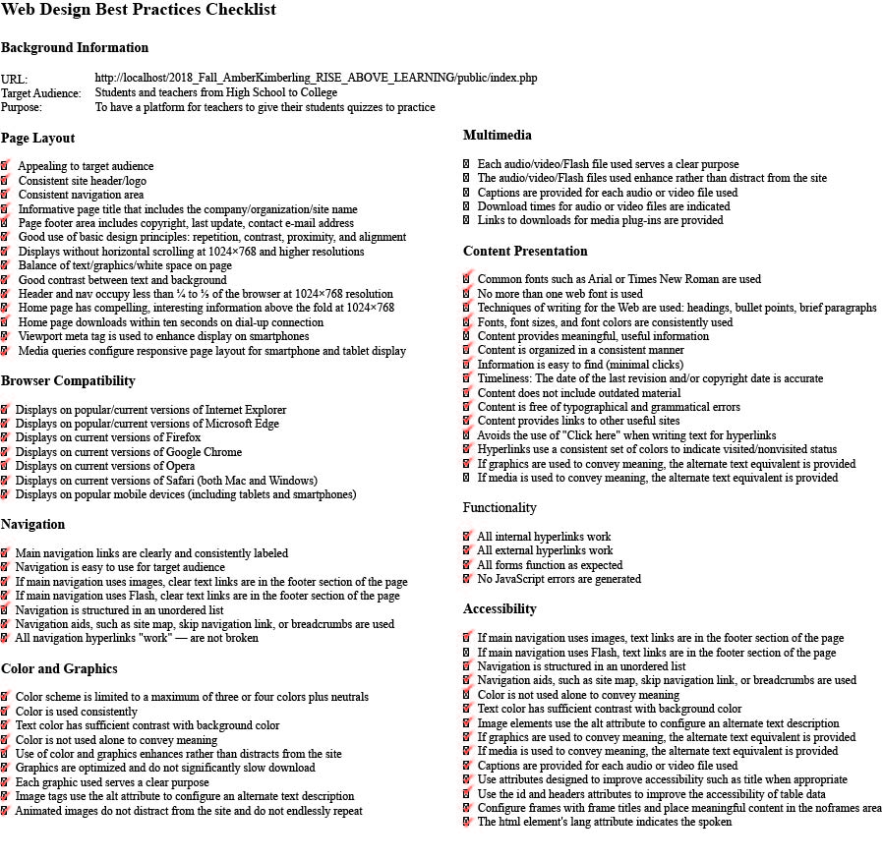

* 1. Test Plan and Results

|  |  |  |  |  |  |
| --- | --- | --- | --- | --- | --- |
| **1. Page #/name** –  **list all pages** | **2. Test item**  **- list** **hyperlinks,**  **fields, buttons, videos,**  **images,**  **GUI controls, web pages**  **Schema: click**  **action =>** reaction  **Legend:**  => means  land in | **3. Validation each web page using** [**http://validator.w3.org**](http://validator.w3.org/) **and**  [**http://jigsaw.w3.org/css-validator/**](http://jigsaw.w3.org/css-validator/) **,** [**https://www.piliapp.com/javascript-validator/**](https://www.piliapp.com/javascript-validator/)**,** [**https://phpcodechecker.com/**](https://phpcodechecker.com/) **- if applicable;**  **attached screenshots with each page name** | **4. Outcome**  in **Mobile**  **Phone**  **- specify** a device **model,** **version**  **and source code web server location (- specify your URL** | **5. Outcome in**  - **tablet**.  **Resolution**  **1920x1080**  **Outcome**  in **Chrome or/and Firefox or Internet Explorer (Edge)**  **- specify** a browser **version**  **and source code web server location (- specify your URL** | **6. Outcome in**  - **desktop.**  **Resolution**  **1440*900.**  **Outcome**  in **Chrome or/and Firefox or Internet Explorer (Edge)**  **- specify** a browser **version**  **and source code web server location (- specify your URL** |
| **home.html.php** | home => home.html.php,  about => about.html.php,  quizzes => quizzes.html.php,  categories  =>categories.html.php,  admin-quizzes=>adminquizzes.html.php,  admin-categories=>admincategories.html.php,  Login =>login.html.php,  users=>userlist.html.php,  registration  =>registration.html.php,  q/a => qa.html.php,  contact=>contact.html.php |  |  |  |  |
| **about.html.php** | home => home.html.php,  about => about.html.php,  quizzes => quizzes.html.php,  categories  =>categories.html.php,  admin-quizzes=>adminquizzes.html.php,  admin-categories=>admincategories.html.php,  Login =>login.html.php,  users=>userlist.html.php,  registration  =>registration.html.php,  q/a => qa.html.php,  contact=>contact.html.php |  |  |  |  |
| **quizzes.html.php** | home => home.html.php,  about => about.html.php,  quizzes => quizzes.html.php,  categories  =>categories.html.php,  admin-quizzes=>adminquizzes.html.php,  admin-categories=>admincategories.html.php,  Login =>login.html.php,  users=>userlist.html.php,  registration  =>registration.html.php,  q/a => qa.html.php,  contact=>contact.html.php |  |  |  |  |
|  | Name of quiz => takequiz.html.php |  |  |  |  |
| **categories.html.php** | home => home.html.php,  about => about.html.php,  quizzes => quizzes.html.php,  categories  =>categories.html.php,  admin-quizzes=>adminquizzes.html.php,  admin-categories=>admincategories.html.php,  Login =>login.html.php,  users=>userlist.html.php,  registration  =>registration.html.php,  q/a => qa.html.php,  contact=>contact.html.php |  |  |  |  |
| **Userllist.html.php** | home => home.html.php,  about => about.html.php,  quizzes => quizzes.html.php,  categories  =>categories.html.php,  admin-quizzes=>adminquizzes.html.php,  admin-categories=>admincategories.html.php,  Login =>login.html.php,  users=>userlist.html.php,  registration  =>registration.html.php,  q/a => qa.html.php,  contact=>contact.html.php |  |  |  |  |
| **adminquizzes.html.php** | home => home.html.php,  about => about.html.php,  quizzes => quizzes.html.php,  categories  =>categories.html.php,  admin-quizzes=>adminquizzes.html.php,  admin-categories=>admincategories.html.php,  Login =>login.html.php,  users=>userlist.html.php,  registration  =>registration.html.php,  q/a => qa.html.php,  contact=>contact.html.php |  |  |  |  |
| **admincategories.html.php** | home => home.html.php,  about => about.html.php,  quizzes => quizzes.html.php,  categories  =>categories.html.php,  admin-quizzes=>adminquizzes.html.php,  admin-categories=>admincategories.html.php,  Login =>login.html.php,  users=>userlist.html.php,  registration  =>registration.html.php,  q/a => qa.html.php,  contact=>contact.html.php |  |  |  |  |
|  | tested separately:  username,  password,  login button =>login |  |  |  |  |
| **registration.html.php** | home => home.html.php,  about => about.html.php,  quizzes => quizzes.html.php,  categories  =>categories.html.php,  admin-quizzes=>adminquizzes.html.php,  admin-categories=>admincategories.html.php,  Login =>login.html.php,  users=>userlist.html.php,  registration  =>registration.html.php,  q/a => qa.html.php,  contact=>contact.html.php |  |  |  |  |
|  | tested separately:  first name,  last name,  email,  password,  register |  |  |  |  |
| **qa.html.php** | home => home.html.php,  about => about.html.php,  quizzes => quizzes.html.php,  categories  =>categories.html.php,  admin-quizzes=>adminquizzes.html.php,  admin-categories=>admincategories.html.php,  Login =>login.html.php,  users=>userlist.html.php,  registration  =>registration.html.php,  q/a => qa.html.php,  contact=>contact.html.php |  |  |  |  |
| **contact.html.php** | home => home.html.php,  about => about.html.php,  quizzes => quizzes.html.php,  categories  =>categories.html.php,  admin-quizzes=>adminquizzes.html.php,  admin-categories=>admincategories.html.php,  Login =>login.html.php,  users=>userlist.html.php,  registration  =>registration.html.php,  q/a => qa.html.php,  contact=>contact.html.php |  |  |  |  |
| **Logout** | logoutbutton=>logout |  |  |  |  |
| **index.php** |  |  |  |  |  |
| **Autoload.php** |  |  |  |  |  |
| **DatabaseConnection.php** |  |  |  |  |  |
| **Authentication.php** |  |  |  |  |  |
| **DatabaseTable.php** |  |  |  |  |  |
| **EntryPoint.php** |  |  |  |  |  |
| **Markdown.php** |  |  |  |  |  |
| **Routes.php** |  |  |  |  |  |
| **RaldbRoutes.php** |  |  |  |  |  |
| **Controllers** |  |  |  |  |  |
| **Category.php** |  |  |  |  |  |
| **Login.php** |  |  |  |  |  |
| **Quiz.php** |  |  |  |  |  |
| **Register.php** |  |  |  |  |  |
| **Entity** |  |  |  |  |  |
| **Category.php** |  |  |  |  |  |
| **Quiz.php** |  |  |  |  |  |
| **User.php** |  |  |  |  |  |
| **ral.js** |  |  |  |  |  |
| **rals.css** |  |  |  |  |  |

# **Conclusion**

In addition, I have created a web application that allows teachers to provide quizzes for students to take and that provides the results instantaneously. It has two types of users differentiated by their permissions. Teachers have full admin capability including managing user permissions, adding, editing, and deleting quizzes and categories. Students can take the quizzes and add categories they wish to have quizzes added too by teachers. The website has a database management system and uses MySQL to add, edit, and delete contents from the website into the database. It also includes a few other general pages like a home, about, q and a, and a contact page. The web application conforms to the Web Design Best Practices Checklist at <http://terrymorris.net/bestpractices> and all the links and code have been tested through validators and by hand.

During the process of creating the web application I learned that coming up with a concept that conforms to the time limitations is very important. Originally, I had planned to have so much more in my website but due to the time restrictions I had to simplify my project. I also learned that allowing fellow students to test you web app out is key in finding flaws within your project. I fixed so many errors at the beginning that I learned the importance of error handling and how the code fully works when you change certain parts. In the future I hope to implement all the plans I originally had for my web application such as physically adding in quizzes to take and separating the users into two different tables. I also would like to make it so that students would be related to a teacher and that teacher can view the students’ grades. I would like to make the quizzes more like a jeopardy multiple choice quiz as well.

In order to create this web application, I needed Internet Applications and Publishing on the web one and two. The Internet Applications course helped the most especially when it came to how the website interacted with the database. On my own I learned how to fix errors and how to read and display information from text files using php. I also experienced how to manipulate portions of code.

# **References**

**[1]** Terry Felke-Morris, *Web Development & Design Foundations* *with HTML* 5 9/E, Addison Wesley Higher Education - Pearson, 2019, Print ISBN-10: 0134801148, Print ISBN-13: 978-0134801148.

**[2]** PHP & MySQL Novice to Ninja, 6th edition by Kevin Yank, Tom Butler, SitePoint Pty. Ltd., November 2017, ISBN13: 978-0994346988, ISBN-10: 0994346980.

# **Appendices**

* 1. Appendix A: Proposal

UNIVERSITY OF LA VERNE

LA VERNE, CALIFORNIA

FALL 2018

SENIOR PROJECT PROPOSAL

**RISE ABOVE LEARNING**

A SENIOR PROJECT SUBMITTED TO:

THE FACULTY OF

COMPUTER SCIENCE AND COMPUTER ENGINEERING

IN CANDIDANCY FOR THE DEGREE OF

BACHELORS OF SCIENCE

COMPUTER SCIENCE AND COMPUTER ENGINEERING

WITH A CONCENTRATION IN INTERNET PROGRAMMING

(OR PUT YOUR CONCENTRATION)

BY

AMBER KIMBERLING

**Faculty Advisor: Prof. Jozef Goetz**

**Table of Contents**

1. Personal Background 63

2. Introduction 63

3. Organizational Overview 63

4. Problem Statement 63

5. Proposed Project and the Scope of the Project 63

6. User Requirements for the Web Application Project 64

7. Website/Web Application Design Requirements to the User Requirements Specification 65

8. Implementing the Design for the Proposed Website/Web Application Design 68

6. Testing Procedure for the Proposed Web Application 73

7. Development Time Frame and Cost 76

8. Primary contact person include 76

9. Approvals 77

# **Personal Background**

My name is Amber Kimberling and my concentration is Internet Programming. My interest in web development started a couple of years ago when I attended The Fashion Institute of Design and Merchandising (FIDM). I had my first UX design class my fourth quarter at FIDM. My teacher Mr. Crawford made working with code very hard because of the way he taught. After the 10 weeks of that class I never wanted to touch code. Then my fifth quarter came around and I had a new professor, Hawk. He taught me how everything I learned in UX design in one day of web design class. After that I began my obsession with creating websites with code. I began experimenting with different CSS and JQuery code. After graduating from FIDM my passion didn’t stop there, I began developing websites for clients and friends. I started getting curious about what more I could do with code so I applied to La Verne and a couple other schools. My passion has only gotten bigger since.

# **Introduction**

The proposed project is about helping teachers become more aware of what their students don’t understand in class. Students often don’t share their questions with their teachers so when comes to a test they are more than likely to guess instead of be confident in what know. This web application will be used to break the communication barrier between students and teachers so they can help their students be successful in the classroom.

# **Organizational Overview**

This is for a high school history teacher who really puts in the effort to make sure the students are understanding what is being taught in class.

# **Problem Statement**

The problem is there isn’t a current user-friendly web application for teachers to test their students that sends teachers statistics about their student’s results. Today there are a lot of applications that test students but fail to store the specific statistics like most missed questions and the teacher is left with individual scores and a total average.

# **Proposed Project and the Scope of the Project**

The goal of this project is to develop a web application that stores quizzes and quiz data from each individual student that will be sent to the teachers email. A relational database will be used that consists of quizzes, categories, students, and teachers. The web application will include administration capabilities, which will allow teachers to set permissions, edit, delete, and insert. The website will consist of multiple web pages that will limit accessibility depending on your permissions as a user. Teachers will have access to all pages including manage students, quizzes, and categories. Student users will have access all pages but will not have the permission to edit, delete, or insert. General visitors to the website will only have access to the home page and about otherwise they will be denied access to all other pages. Overall the purpose of this web application is to test students in a positive psychologically stimulating way through fun quizzes based off chapters, sections, or topics. The teacher will receive the statistics on their student’s results and the teacher will then be able to emphasize what their students don’t understand.

# **6. User Requirements for the Web Application Project**

1. Web Page Design
   1. The website should conform to the Web Design Best Practices Checklist

[**http://terrymorris.net/bestpractices**](http://terrymorris.net/bestpractices)

1. Website Navigation
2. The navigation should be consistent throughout every page
3. A text based navigation should be implemented in the footer for users who are disabled
4. Breadcrumb trails should be used when/if a deep hierarchy is used
5. Page Layout Design
   1. Breadcrumb trails
   2. The website should appeal to the audience who would be viewing it
   3. The website should have a consistent header/footer/navigation throughout each page
   4. Pertinent page information should be located in the footer
   5. Page should be viewable in 1024x768 resolution with no horizontal scrolling
   6. The contrast between the background and content should be strong to ensure ease while reading
   7. The website should have a logical alignment of content
   8. The homepage of the website should load in a reasonable amount of time for a 56 kbps connection
   9. There should be a good balance between content and whitespace
   10. Optimize layout for mobile use as follows:
       * 1. Single column design
         2. Limit scrolling to one direction
         3. Use heading elements
         4. Use lists
6. Color and Graphics
   * 1. The color of the website should be appealing to the eye, but should maintain a loose business feeling (no dark colors)
     2. Color should be used consistently throughout the entire website
     3. Color should not be used exclusively to convey meaning
     4. Graphics should not have a significant impact on the loading time of the website
     5. The alt attribute should be used on all images
7. Content Presentation
   * 1. Information should be easy to find within the website
     2. Common fonts should be used (Times New Roman, Arial, Sans serif, etc.)
     3. Content organization should follow a consistent pattern
     4. Font sizes, font color, and font style should remain consistent
8. Accessibility
   * 1. The alt tag should be used on any images or videos
     2. Captions should be used on any video content
     3. “Web safe” colors should be used
     4. Proper navigation should be used to help accessibility (bread crumb trails, text based navigation)
9. Special Requirements
   * 1. The website should provide for the owner to easily update, create, delete, etc. pages in a quick and simple way
     2. The website should provide a means of communication between the users of the website
10. Mobile Best Practice Requirements

The website will conform to the best practices on the following:

<http://www.w3.org/2007/02/mwbp_flip_cards.html>

<https://www.sitepoint.com/7-best-practices-designing-mobile-user-experience/>

<https://designmodo.com/responsive-design-examples/>

# **7. Website/Web Application Design Requirements to the User Requirements Specification**

1. Rise Above Learning Site Map that displays the pages accessible to different users and it displays the flow of the website.



1. Functional Diagram displaying the user flow between the administrator and user.



1. Website wireframe that displays the organization and the different devices. (full set of wireframes will be shown on the final document)





1. Database relationship table and chart showing the how each table relates to one another.

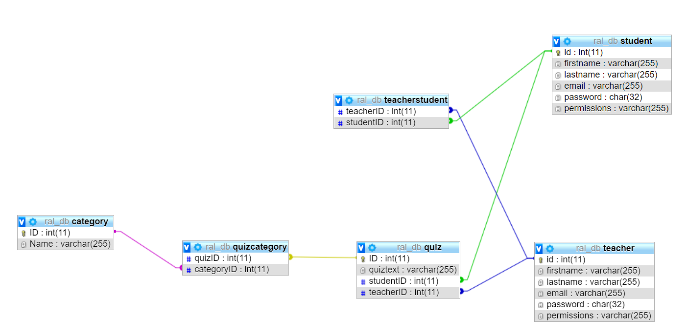

**NOTE**:

* 1. columns in **bold** are **primary** keys,
  2. columns in *italic* are *foreign* keys,
  3. the order of tables is matching with the order of the table relationship.

|  |  |  |  |
| --- | --- | --- | --- |
| **Joke Management System tables** | **Joke Management System table columns** | **My project tables** | **My project table columns** |
| category | **id**, name | category | **id**, name |
| jokecategory | ***jokeid, categoryid*** | quizcategory | *quizid****,*** *categoryid* |
| joke | **id**, joketext, jokedate, *authorid* | quiz | **id**, quiztext, quizdate, *studentid,teacherid* |
| **author** | **id**, name, email, password, permissions | **student** | **id**, name, email, password, permissions |
|  |  | **teacher** | **id**, name, email, password, permissions |
|  |  | **teacherstudent** | *teacherid, studentid* |

1. Case diagram showing each users access capabilities.



# **8. Implementing the Design for the Proposed Website/Web Application Design**

**The following objectives will be achieved:**

**1. Website implementation** - A graphical hierarchy of files and relationships. (full set of graphical hierarchy will be shown on the final document)

|  |  |  |  |
| --- | --- | --- | --- |
| **Directories**  **Ch14 AllJokes** | **File Names with a short description** | **“Includes” File Names and Function Names** | **Included**  **Headers** |
| **includes** | **DatabaseConnection**.php – connect to the database and supply a connection string parameters such as a **host** **name**, a **databasename**, an **user name** and a **password.** |  |  |
|  | **autuoload.php -** enabling for classes to be automatically loaded if they aren’t currently defined. By registering the autoloaders, it is a last chance to load the class before it fails. | function autoloader($className) |  |
| **templates** | **addquiz**.php – inserts a quiz that was from **addquiz**.html.php into the database database.sql, calls insertquiz() | **DatabaseConnection**.php  **autoload**.php  insertquiz()  **addquiz**.html.php  **layout**.html.php | **quizzes**.php |
|  | **deletequiz**.php – deletes a quiz when the delete button is pressed in quizzes.html.php, calls deletequiz() | **DatabaseConnection**.php  **autoload**.php  deletequiz ()  layout.html.php | **quizzes**.php |
|  | **registersuccess**.html.php –  displays that the registered successfully |  |  |
|  | **logout**.html.php –  displays that the user is logged out. |  |  |
| **public** | **index.**php **–**  uses a try and catch block to catch an error if the page does not load |  |  |
| **classes - ral** | **ralRoutes**.php –  navigation through the website and uses functions to check permissions and authentification. | **public function __construct()**  **public function getRoutes(): array**  **public function getAuthentication():**  **public function checkPermission($permission): bool** |  |
| **classes – ral - controllers** | **Category.php**  using functions to allow the categories to be edited, deleted, entered, and displayed in a list | **public function __construct(\Ninja\DatabaseTable $categoriesTable, \Ninja\DatabaseTable $quizCategoriesTable)**  **function edit()**  **public function saveEdit()**  **public function list()**  **public function delete()** |  |
| **classes - entity** | **teacher.php**  sets the user permissions and uses functions to set the permissions like show quizzes and allow editing capabilities. | **public function __construct(\Ninja\DatabaseTable $quizTable)** |  |
| **classes – ninja** | **authentification.php**  uses functions to authentificate a users information | **public function __construct(DatabaseTable $users, $usernameColumn, $passwordColumn)**  **public function login($username, $password)**  **public function isLoggedIn()** |  |

b. A database implementation – screenshots of columns with data types and data records. (full set of database implementation will be shown on the final document)

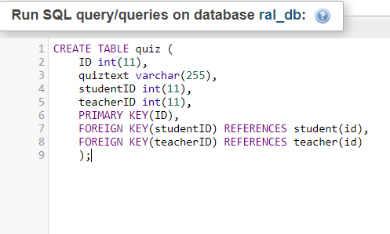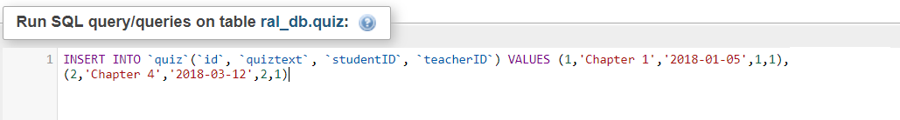

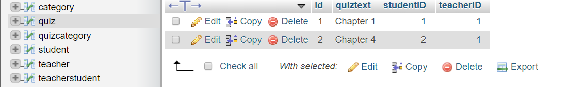

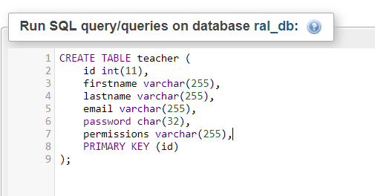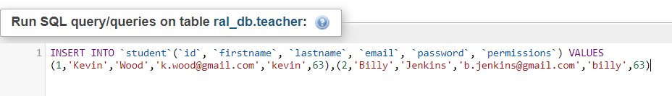

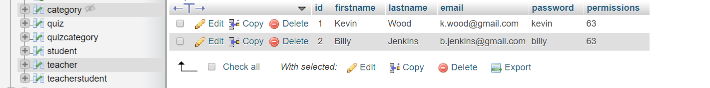

1. Web Page Design

a. The website will be designed to ensure that the conditions of the web design best practices are met. These conditions will be kept in mind while editing and creating new pages.

1. Website Navigation
   1. The website will have a multiple sources of navigation.  First, there will be the main navigation that will be either at the top of the website or on the side in one of the columns.  There will be a text based navigation in the footer to allow for accessibility for those who are disabled or who do not have browsers with CSS capabilities.
2. Page Layout Design
   * 1. Cascading Style Sheets will be used to create a  two column structure which will allow for maximum functionality and multiple places to put information.
     2. Media queries will configure **responsive page layout** for **smartphone** and **tablet display.**
     3. A Liquid design will be used in order to adapt itself to the available white space, which may vary between people using different resolutions.
     4. The website will be designed with the Arial font and colors that are contrasting.  This will allow for maximum accessibility.
     5. Most of the important information will be located above the fold so that it is faster to access.
     6. Website will be designed with multiple resolutions in mind to ensure accessibility to those with lower resolution monitors.  Also, white space will be balanced for those who do have access to larger resolutions.
     7. The website will be designed to load in a reasonable amount of time (usually under 10 seconds) for those who are on dial up.  A perceived load time faster than that would be ideal.
3. Color and Graphics
   * 1. Color will be appealing but still maintain a business-like feeling.  Dark colors will be avoided, as will very bright colors that might be hard to read or give certain individuals problems with reading.  Web safe colors will be used to ensure that all users see the same color.
     2. Color will be used consistently throughout the entire site.
     3. Color will not be used to convey meaning alone.
     4. The alt attribute will be used on all videos and pictures.
     5. The graphics should be optimized to ensure that the load time of the website is not severely affected.
4. Content Presentation
   * 1. Most important information will be located “above the fold” to ensure that information can be found quickly and easily and the user does not have to do a lot of scrolling.
     2. Colors and themes will be used consistently throughout every page.
     3. Arial font will be used.  A widely supported font.
     4. Major changes will not be made to the organization of a page. The organizational structure of the page will stay consistent.
5. Accessibility
   * 1. Captions will be used on all videos.

# **9. Testing Procedure for the Proposed Web Application**

1. The website will be tested for compatibility and organization in all current major browsers, including: Mobile Phones, Google Chrome, Mozilla Firefox, Microsoft Edge, Safari, and Opera.
2. Multiple resolutions will be tested, including smart phones, tablets and desktops – see the TABLE below.
3. All pages will be validated at <http://validator.w3.org/>
4. All CSS will be validated at <http://jigsaw.w3.org/css-validator/>
5. Each web page of the website will be tested according the test items specified in the table below. The website will be used **test cases** for inputs, execution instructions, and expected results to determine whether a specific software feature works correctly or a specific requirement has been satisfied.
6. The website will be tested thoroughly from the user perspective (**use cases**). All links, buttons, images, videos will be tested to ensure that all are in proper working order and that there are no broken links.

**TABLE Test plan and results - Verification Matrix:** (full set of testing table be shown on the final document)

|  |  |  |  |  |  |  |  |
| --- | --- | --- | --- | --- | --- | --- | --- |
| **Page name** –  **list all pages/files** | **Test item**  **- list** **hyperlinks,**  **fields, buttons, videos,**  **images,**  **GUI controls, web pages**  **Schema: select action => reaction**  **Legend:**  => lands in | **Validation web pages using** [**http://validator.w3.org**](http://validator.w3.org/) **and**  [**http://jigsaw.w3.org/css-validator/**](http://jigsaw.w3.org/css-validator/) **- if applicable;**  **attached screenshots** with a page name | **Validation** your **JavaScript** code – specify a **validator nam**e**;**  **attached screenshots** with a page name | **Validation** your **PHP or C#** code (if aplicable) | **Outcome**  in **Mobile**  **Phone**  **- specify** a device **model,** **version**  **and source code web server location (- specify your URL** | **Resolution**  **1920x1080**  - **tablet**  **Outcome**  in **Chrome or/and Firefox or Internet Explorer**  **- specify** a browser **version**  **and source code web server location (- specify your URL** | **Resolution**  **1440*900.**  - **desktop**  **Outcome**  in **Chrome or/and Firefox or Internet Explorer**  **- specify** a browser **version**  **and source code web server location (- specify your URL** |
| **User Management System -UMS** | Links:  Manage users => manage users,  Manage categories => manage categories,  Manage quizzes => manage quizzes |  |  |  |  |  |  |
| **Login** | **LOGGED OUT:**  home => home.html.php,  about => about.html.php,  adminLogin =>admin.html.php,  registration  =>registration.html.php, contact=>contact.html.php  **LOGGED IN:**  home => home.html.php,  about => about.html.php,  quizzes => quizzes.html.php,  categories  =>categories.html.php,  logout=>logout.html.php,  students=>students.html.php,  registration  =>registration.html.php,  contact=>contact.html.php |  | *Test upon completion of individual pages* | *Test upon completion of individual pages* | *Test upon completion of individual pages* | *Test upon completion of individual pages* | *Test upon completion of individual pages* |
| **Contact** | **LOGGED OUT:**  home => home.html.php,  about => about.html.php,  adminLogin =>admin.html.php,  registration  =>registration.html.php, contact=>contact.html.php  **LOGGED IN:**  home => home.html.php,  about => about.html.php,  quizzes => quizzes.html.php,  categories  =>categories.html.php,  logout=>logout.html.php,  students=>students.html.php,  registration  =>registration.html.php,  contact=>contact.html.php |  | *Test upon completion of individual pages* | *Test upon completion of individual pages* | *Test upon completion of individual pages* | *Test upon completion of individual pages* | *Test upon completion of individual pages* |

# **10. Development Time Frame**



# **Primary contact person include**

Name: Amber Kimberling

Address: 415 Churchilll Road, Sierra Madre CA 91024

Phone number: (626) 940 – 6280

E-mail: amber.kimberling@laverne.edu

# **Approvals**

1. Name: Prof. Ahmad Abushanab Signature: ________________Date_______

2. Name: Prof. Ray Ahmadnia Signature: ________________Date_______

2. Name: Prof. Jozef Goetz Signature: ________________Date______

3. Name: Prof. Seta Whitby Signature: ________________Date_______

* 1. Appendix B: Presentation



